Fundamentals of Programing

Lab Manual # 10

**Lab Instructor:** Muhammad Affan

## Student Name: Ahmad Aleem Akhtar

## CMS ID: 458945

**DATE:**

**28-12-23**

**Task 1:**

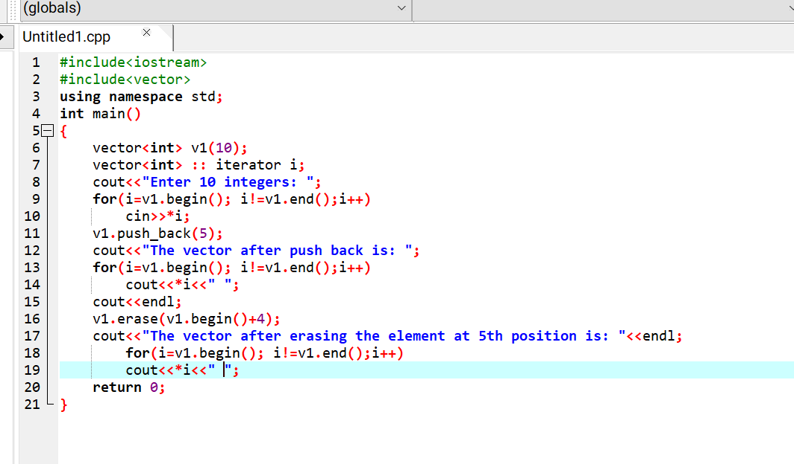

**Output:**

**Task 2:**

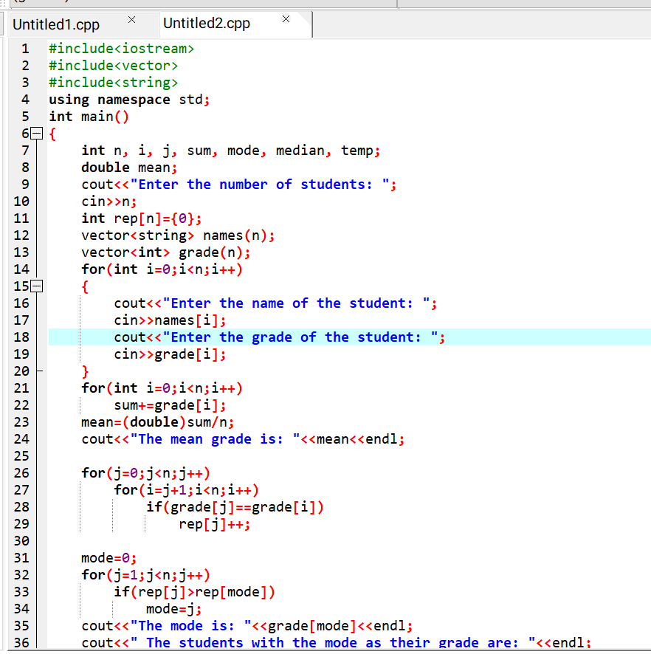

**Output:**

